Case Study
AI Chatbot for Customer Service Automation
Used Technologies: Generative AI, Large Language Models (LLMs), OpenAI GPT-4, LangChain, Retrieval-Augmented Generation (RAG), React, TailwindCSS, Node.js, FastAPI, Docker, Google Cloud Run, Dialogflow, Webhooks

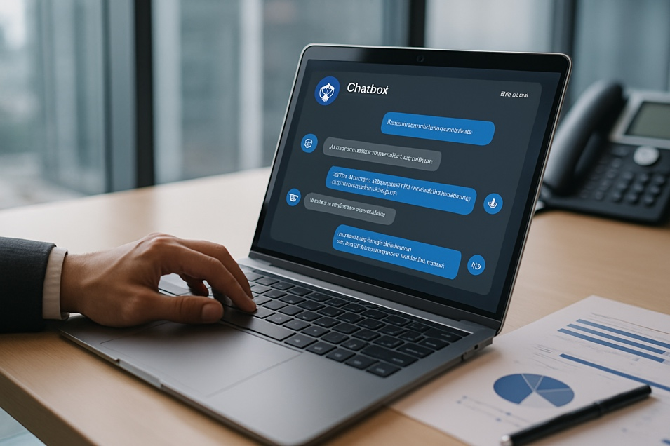
Executive Summary
Robles.AI partnered with a multinational telecommunications company to develop and deploy a Generative AI chatbot capable of handling the majority of customer service inquiries.
Within two months of implementation, the system managed to autonomously resolve 78% of incoming requests, reduced response time by 85%, and improved customer satisfaction by 32%.
This implementation represents a transformative leap in scalable customer engagement solutions.

System Components and Architecture
- Generative AI Core: Powered by OpenAI GPT-4 and enhanced via LangChain for prompt chaining and contextual memory.
- Knowledge Base Integration: Connected to the company's internal documentation and FAQs through a RAG pipeline.
- Multichannel Interface: Integrated via web widget, WhatsApp Business API, and Facebook Messenger.
- Orchestration Layer: Node.js backend with FastAPI services handling session management, routing, and escalation.
- Deployment: Containerized with Docker and deployed to Google Cloud Run for elastic scalability.
- Monitoring and Feedback: Analytics dashboard built with React and Tailwind for tracking resolution rates, CSAT, and escalation rates.

Project Stages
- Discovery and Requirements
  - Interviewed customer support agents and reviewed historical tickets.
  - Identified 12 most common user intents covering 78% of tickets.
- Model Integration and Prototyping
  - Fine-tuned prompts and memory buffers using LangChain.
  - Built initial conversation flows and tested via Dialogflow simulator.
- Deployment and User Testing
  - Soft-launched on a limited user base.
  - Collected feedback from 1,500+ sessions.
  - Rolled out enterprise-wide after two weeks.
- Performance Monitoring and Iteration
  - Weekly prompt updates based on new intents.
  - Added fallback handlers and escalation triggers.

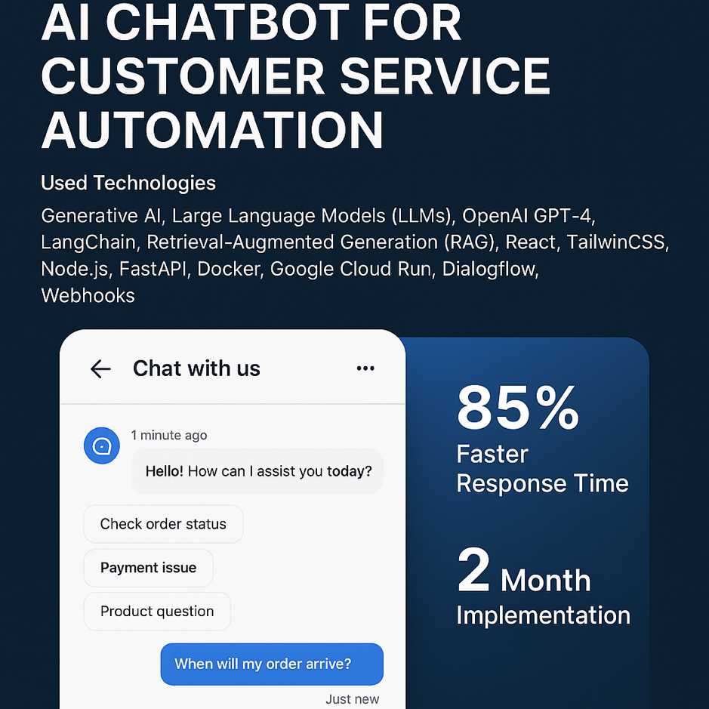
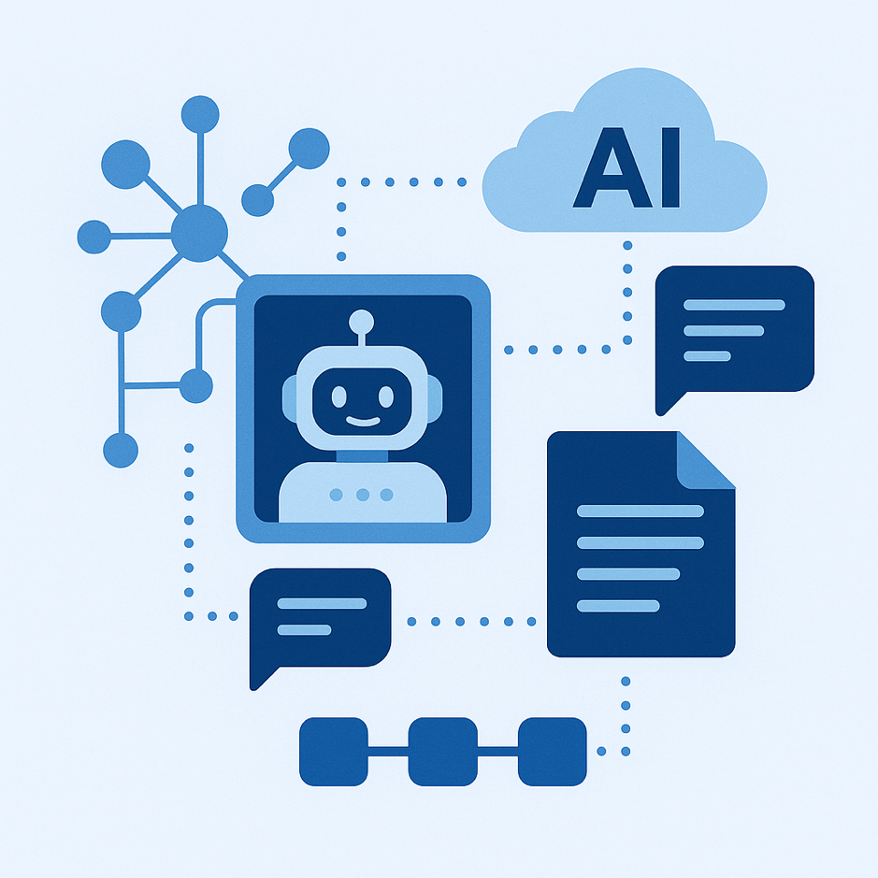
Results Achieved
- 78% of inquiries resolved without human interaction.
- 85% faster average response time.
- 32% increase in customer satisfaction (CSAT).
- Escalation rate decreased by 41%.
Business Impact
The AI chatbot significantly reduced the workload on human agents, allowing them to focus on high-complexity cases. Customers experienced shorter wait times and more consistent interactions. The solution also allowed the company to scale support during promotional campaigns without adding headcount.
The explainable AI module also enabled compliance with internal auditing and legal standards, increasing trust among stakeholders.
Conclusion
The project illustrates the potential of AI-driven chatbots to revolutionize customer service operations. Robles.AI continues to innovate in the space of generative automation, offering scalable, secure, and human-like assistance to enterprises across sectors.
" The AI assistant developed with Robles.AI became our frontline responder overnight. We've cut response times drastically and our agents are now able to handle more meaningful conversations. The impact on our operational efficiency has been nothing short of extraordinary."
— Carlos Herrera, VP of Customer Experience
TelcoOne
Case Study
AI Chatbot for Customer Service Automation

